**Experiment 1**

**Aim:** To implement bubble sort.

**Code:**

1. **Worst Case**

#include <iostream>

using namespace std;

int pass=0, comp=0, swaps=0;

void Bubble_Sort(int *arr, int n){

for(int i=0;i<n-1;i++){

pass++;

for(int j=0;j<n-1-i;j++){

comp++;

if(arr[j]>arr[j+1]){

swaps++;

int temp = arr[j];

arr[j] = arr[j+1];

arr[j+1] = temp;

}

}

cout<<"The array after pass "<<i+1<<" is: ";

for(int k=0;k<n;k++){

cout<<arr[k]<<" ";

}

cout<<endl;

}

}

int main(){

int n;

cout<<"Bubble Sort Algorithm"<<endl;

cout<<"Best Case Time Complexity is: O(n)"<<endl;

cout<<"Worst Case Time Complexity is: O(n^2)"<<endl;

cout<<"Space Complexity is: O(n)"<<endl;

cout<<"Enter the size of an array (Total entries should not be more than 100): ";

cin>>n;

int *arr = new int [100];

cout<<"Enter the array elements: ";

for(int i=0;i<n;i++){

cin>>arr[i];

}

cout<<"The original array is: ";

for(int i=0;i<n;i++){

cout<<arr[i]<<" ";

}

cout<<endl;

Bubble_Sort(arr,n);

cout<<"The sorted array in ascending order is: ";

for(int i=0;i<n;i++){

cout<<arr[i]<<" ";

}

cout<<endl;

cout<<"No of passes is: "<<pass<<endl;

cout<<"No of comparisons is: "<<comp<<endl;

cout<<"No of swaps is: "<<swaps<<endl;

delete arr;

}

1. **Best Case**

#include <iostream>

using namespace std;

int pass=0, comp=0, swaps=0;

void Bubble_Sort(int *arr, int n){

for(int i=0;i<n-1;i++){

pass++;

cout<<"The array after pass "<<i+1<<" is: ";

for(int k=0;k<n;k++){

cout<<arr[k]<<" ";

}

cout<<endl;

}

}

int main(){

int n;

cout<<"Bubble Sort Algorithm"<<endl;

cout<<"Best Case Time Complexity is: O(n)"<<endl;

cout<<"Worst Case Time Complexity is: O(n^2)"<<endl;

cout<<"Space Complexity is: O(n)"<<endl;

cout<<"Enter the size of an array (Total entries should not be more than 100): ";

cin>>n;

int *arr = new int [100];

cout<<"Enter the array elements: ";

for(int i=0;i<n;i++){

cin>>arr[i];

}

cout<<"The original array is: ";

for(int i=0;i<n;i++){

cout<<arr[i]<<" ";

}

cout<<endl;

Bubble_Sort(arr,n);

cout<<"The sorted array in ascending order is: ";

for(int i=0;i<n;i++){

cout<<arr[i]<<" ";

}

cout<<endl;

cout<<"No of passes is: "<<pass<<endl;

cout<<"No of comparisons is: "<<comp<<endl;

cout<<"No of swaps is: "<<swaps<<endl;

delete arr;

}

**Output:**

1. **Best Case**

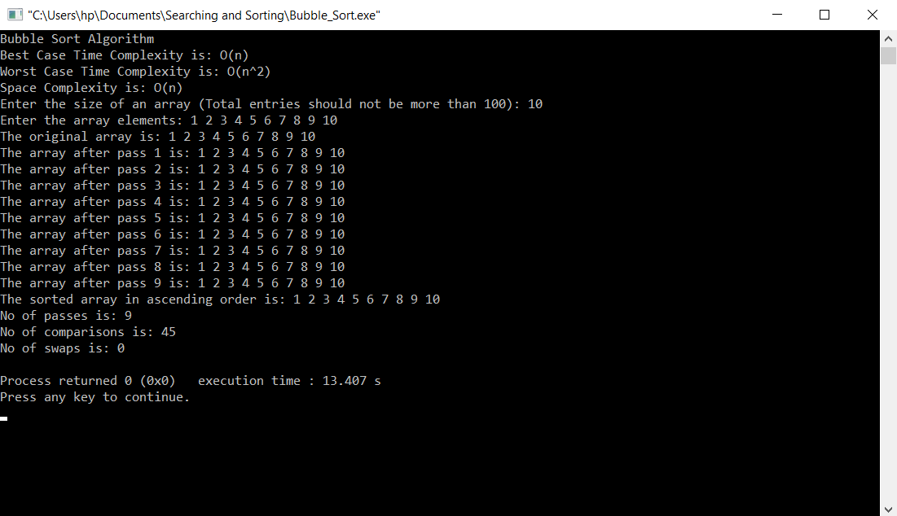

1. **Worst Case**

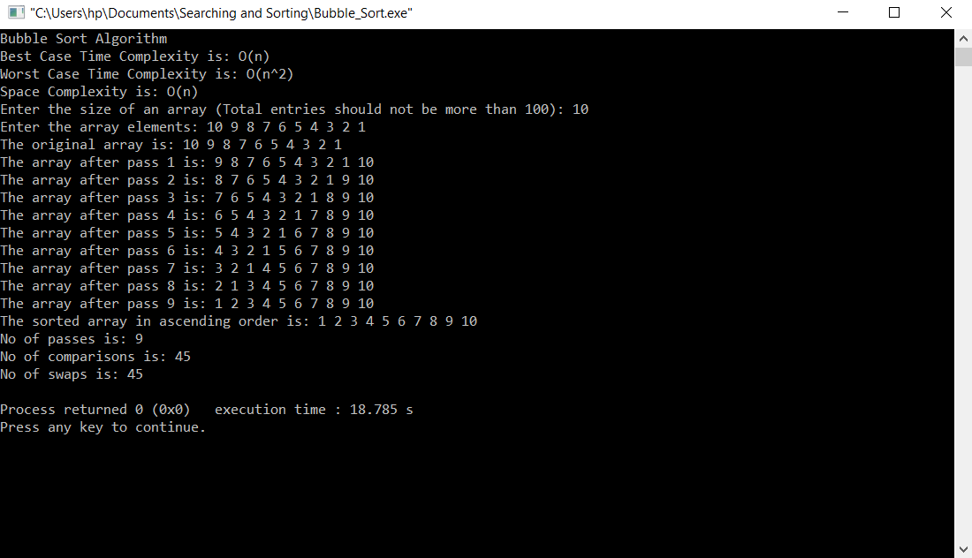

**Conclusion:** The bubble sort sorting algorithm has been implemented successfully.